

Dr. Jeffrey, Smith inc.
2017-04-25
Dr. Smith
38068 Douglas Flat Suite 632, North Ginastad, CA 01288
Phone: 3780242042
Fax: 89489785

Re: Susan, Gould
PHN: 9622284900
Birthdate: 10-Jan-1950
Address: 8486 Andrea Lane Suite 614, New James, KY 36152
Patient number: 9431587670

To Whom It May Concern:

This is a medical letter to state the above patient is pregnant with expected delivery date of 18-Jun-2025. Hoping this information is satisfactory for your requirements.

Thank you.

Sincerely,
Dr. Jeffrey, Smith
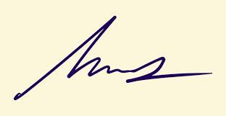
FRCS© NCMP
Clinical Assistant Professor, UBC
Department of Obstetrics and Gynecology SMH

